|  |
| --- |
| Name: RMN Dhananjani |
| Student Reference Number: 10707176 |



|  |  |  |
| --- | --- | --- |
| Module Code: PUSL2002 | Module Name: Web Development Platforms | |
| Coursework Title:  Agriculture website for The Department of Agriculture (DoA) | | |
| Deadline Date: 13/01/2021 | | Member of staff responsible for coursework: Dr.Rasika Ranaweera |
| Programme: BSc (hons) Software Engineering | | |
| Please note that University Academic Regulations are available under Rules and Regulations on the University website [www.plymouth.ac.uk/studenthandbook](http://www.plymouth.ac.uk/studenthandbook). | | |
| Group work: please list all names of all participants formally associated with this work and state whether the work was undertaken alone or as part of a team. Please note you may be required to identify individual responsibility for component parts.   1. 10707299 SRJ Pathiranage 2. 10707425 AN Withanage 3. 10707176 RMN Dhananjani 4. 10707212 CGK Haputhanthri 5. 10707239 RBW Karunarathne 6. 10707280 MKSS Meegoda | | |

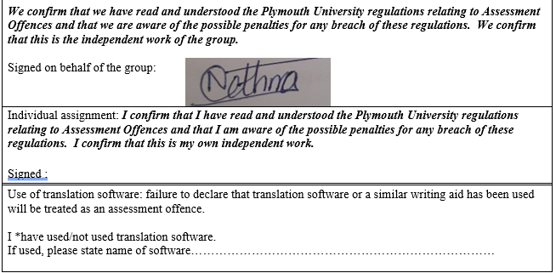

|  |
| --- |
| **Overall mark _____% Assessors Initials ______ Date_________** |

FINAL COURSEWORK REPORT

|  |  |
| --- | --- |
|  |  |
|  |  |
|  |  |

**Group 28**

**PUSL2002**

**Web Development Platforms**

**19.2 Plymouth batch**

**Table of Contents**

**2**

**Acknowledgement 3**

**1. Introduction 4**

**2. Scope and Overview 4**

**3. System Objectives 5**

**4. Specific Requirements 5**

**4.1. Functional requirements 5**

**4.2 Non-functional requirements 7**

**5. Diagrammatic explanations 9**

**5.1 ER Diagram 9**

**5.2 Use Case Diagram 10**

**6. Hardware requirements 11**

**7. Software requirements 11**

**8. System design specification 11**

**9. Assumptions considered in the development 12**

**10. User interfaces 12**

**11. Summary 19**

## **Acknowledgement**

The success and the final outcome of this assignment required a great guidance, encouragement and assistance by many people. I would like to express my gratitude to my module lecturer Dr. Rasika Ranaweera for the excellent guidance and instructions given throughout the course. We would like to express the sincere thanks to him for the assistance, motivation and the encouragement given to us and as well as for the knowledge given via theoretical and practical aspects of web development

## **Introduction**

The developed web application can be defined as a platform designed in order to case the farmers, and keels who purchase their products and even the staff of department of agriculture through a computerized system by automatic most of the tasks happening in the process. The general public is also given the opportunity to view the website & to see various information such as farmers & their locations, statistics of fruits & vegetables sold by the farmers & the analysis of products etc.

The scenario was selected by analyzing the technological advancement happening currently in the country and then it is developed further to carry out more operations in a reliable and comfortable manner effectively.

This dynamic web application is developed with the intention of providing the keels and DoA to handle all the related procedures by maintaining a proper connection with farmers. The system is developed using HTML, CSS and PHP by using SQL database management system. This will deal with all the fundamental and minute details effectively and appropriately according to the user requirements and expectations.

## **Scope and Overview**

Creating a web application for farmers to notify about their cultivation to the Department of agriculture and for Keels supermarkets is the given scenario and the identified scope of the project.

Any farmer can register on system by giving details of the cultivation he does for free.

On the other hand, Department of agriculture and keels can review on the records created by the farmers and they can rate them with the provision of validation to the data inserted by the farmers.

General public will be able to get a glance of the applications purpose success and be tempted to use the application for the better management of their business/cultivation.

The overall development and the implementation of this web project was performed by the group members according to a proper plan and with a high quality and accuracy.

## **System Objectives**

Save farmer data when farmer provides by the time, he harvests the cultivation.

With the use of this application Keels and DoA can evaluate the farmers cultivation and provide them with better prices for their harvest

With the implementation of this project on internet will circulate the harvest of a crop without it getting wasted, because of harvest saturation.

**Initial plan**

Identifying the scope of the project and creating related technical diagrams for the project requirements.

Dividing workload between group members with equal distribution of the weight of the project.

Completing and compiling all the related pages to create a proper functional web application

Connecting MYSQL database to save the user data and connect the application with it.

Create a functional web application which satisfies the given requirements mention in the scope.

## **Specific Requirements**

### 4.1. Functional requirements

* Functional requirements specify the details about the behavior of products and services offered by the web application. These are tasks expected to be performed using the system.
* Functional requirements basically explain the software system and its components. All the inputs, behavior, processes and outputs of the application are categorized under the functional requirements.

**What farmers can do?**

* Register to the website for free
* Input data to created reports
* Delete or update created reports
* Can login to the website at any time
* Report the details of the harvest
* Include evidence such as images within the reports

**What general public can do?**

* View farmer’s reports
* View the graphs
  + Farmer locations
  + Successful transactions
  + Wasted harvest
  + Analysis of types of products

**What does web master can do?**

* Create accounts for keels and DoA staff.

**What does Keels and Department of Agriculture can do?**

|  |  |  |
| --- | --- | --- |
| **action** | **Keels** | **DOA** |
| Login to the website using the login credentials given by the web master |  |  |
| View the reports of farmers |  |  |
| Validate the submitted photos |  |  |
| Evaluate the evidence |  |  |
| Approve reports submitted by the farmers |  |  |
| Communicate with farmers by sending messages |  |  |
| Purchase or ignore products |  |  |
| Set flag based on product quality |  |  |
| See the graphs   * Analysis of product types * Locations of farmers * Successful transactions * Wasted products |  |  |

### Non-functional requirements

* Nonfunctional requirements focus on the criteria which the application is conform to. These non-functional requirements describe the qualities and the characteristics of the developed system.
* Non-functional requirements define the attributes of the designed system.
* They ensure the effectiveness and the quality of the system:
* Security
* Reliability
* Performance
* Maintainability
* Compatibility
* Ability to perform extensions and developments
* Availability of 24x7
* Minimum response and loading time
* Data integrity
* Capacity
* Efficiency

## **5. Diagrammatic explanations**

### 5.1 ER Diagram

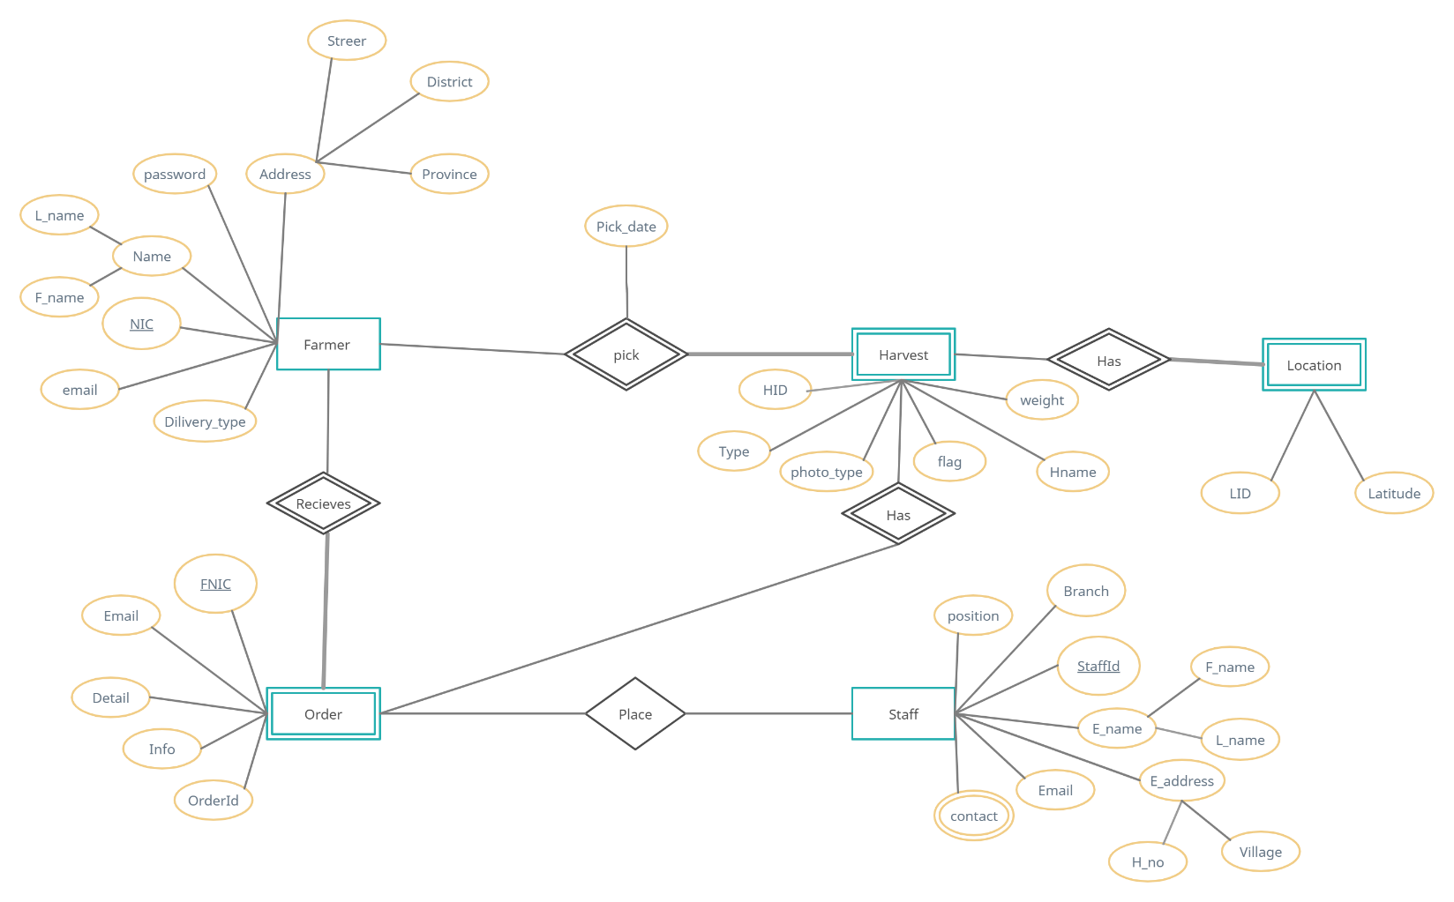

### 5.2 Use Case Diagram

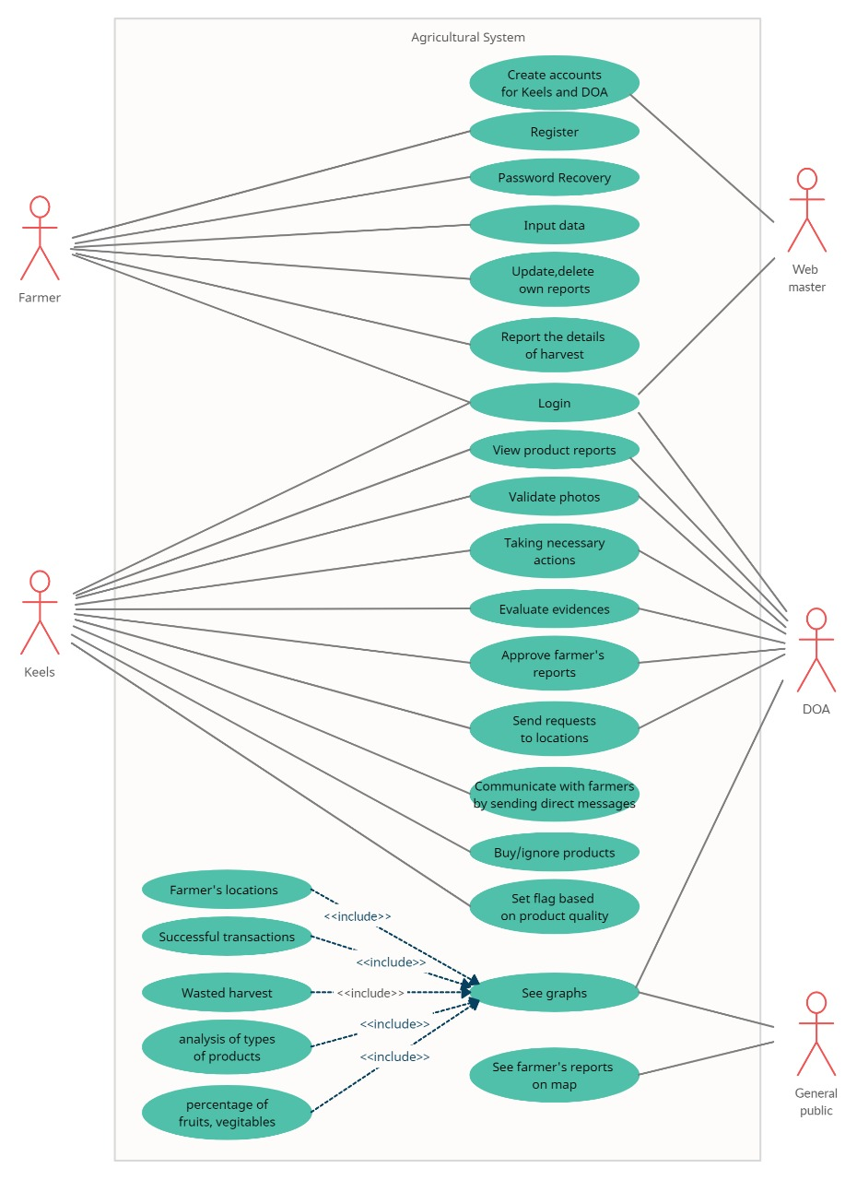

## **6. Hardware requirements**

For a better performance, the following hardware requirements should be met.;

* Processor – Minimum Core i3
* RAM – 2GB/ 4GB
* VGA – Minimum 512MB

## **Software requirements**

Used:

XAMPP,

Sublime text

visual studio code

## **8. System design specification**

In the system design, the following tasks are identified:

* Identification of software components and the architecture of the software

The components are identified, and the system is designed in a way that all the software components are inter-related. This is mainly called as the software architecture. This software architecture is converted into a system which is compatible and operatable with the computer.

* Interface designing

The user connects with the system through the system interface and do the necessary tasks through that. So, proper interface designing enhances the convenience of using the system. The interface is always deigned in an attractive way.

* Database designing

In database designing, the necessary data required for the entire system should be identified and saved in the system database.

## **9. Assumptions considered in the development**

* The users have the basic computer literacy.
* The users have the basic English knowledge to deal with the online web application
* Availability of a proper internet connection
* The entered details are true and fair
* The users will avoid fraud in all kinds of transactions
* Designed software components will function accurately in third party operating systems.
* The hardware components are compatible with the system on every occasion.

## **10. User interfaces**

Login

In the login page, users can login to the system using their username and password which were given at the point of creation of their account. In addition to that they can use their role as well before login whether he is a farmer, keels staff or DOA staff. In a case where the user has forgotten his password, he has the option to recover it by clicking on the “Forgot password” option.

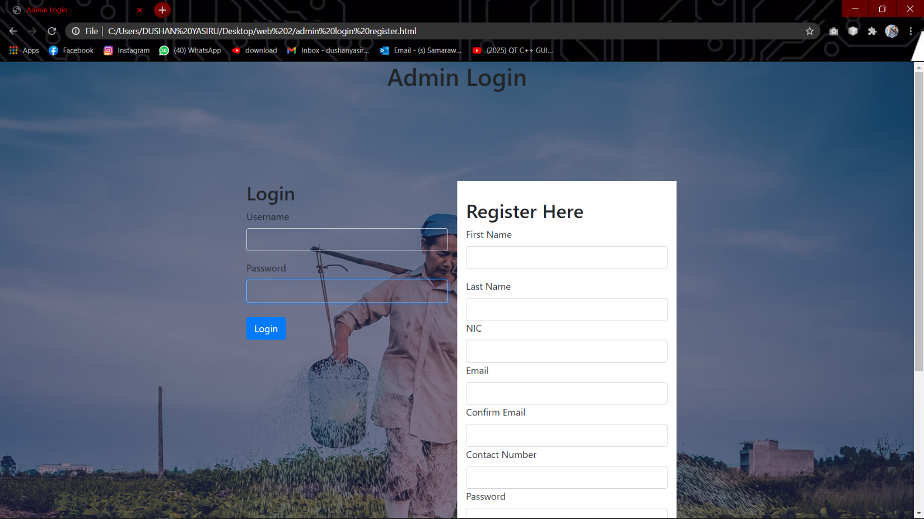

Registration

The registration/signup page allows the user to create an account on their own. Here, the users are required to complete a registration form. Additionally, a username and a password should also be provided as the login credentials to access the system in future. From this window a farmer can register on the webpage and add the description about the cultivation he/she does.

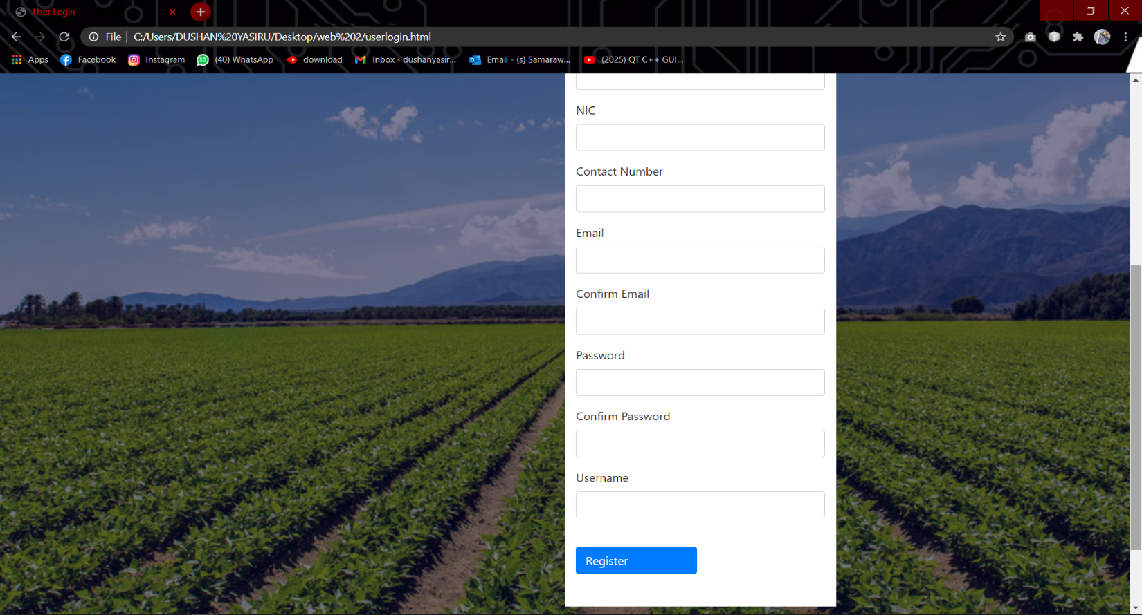

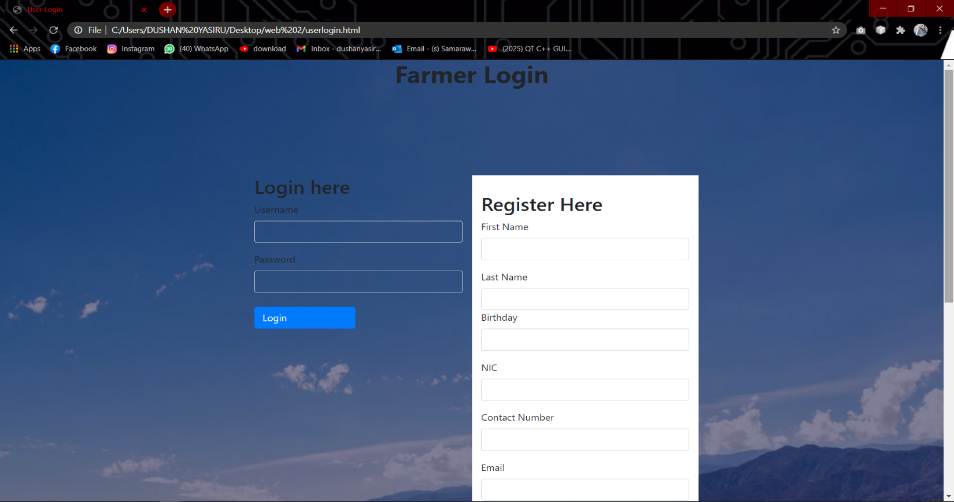

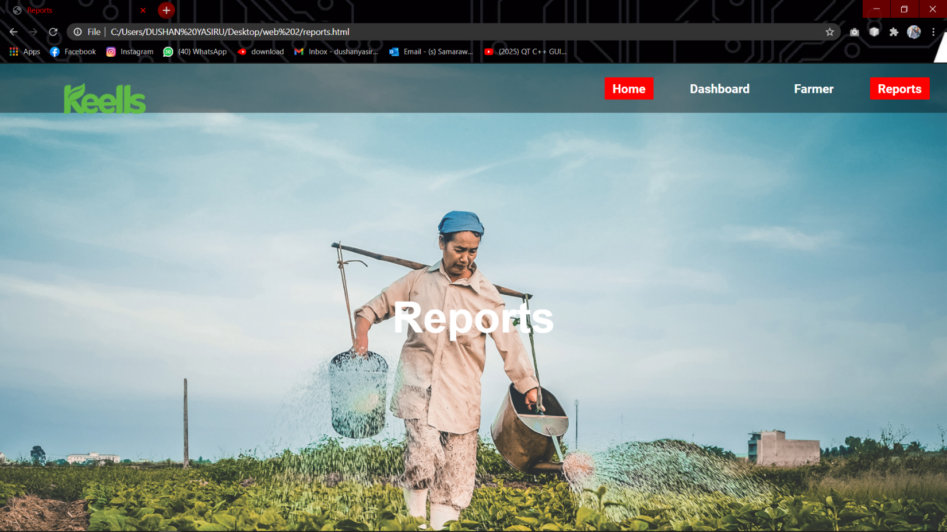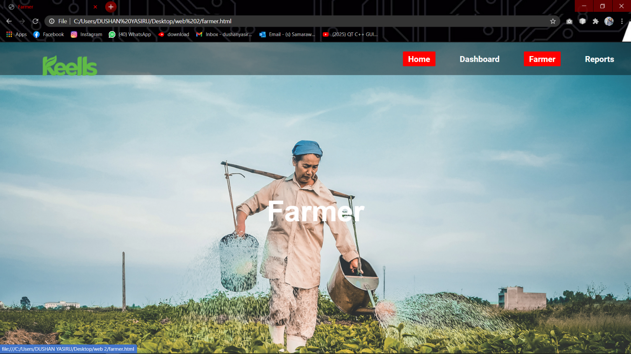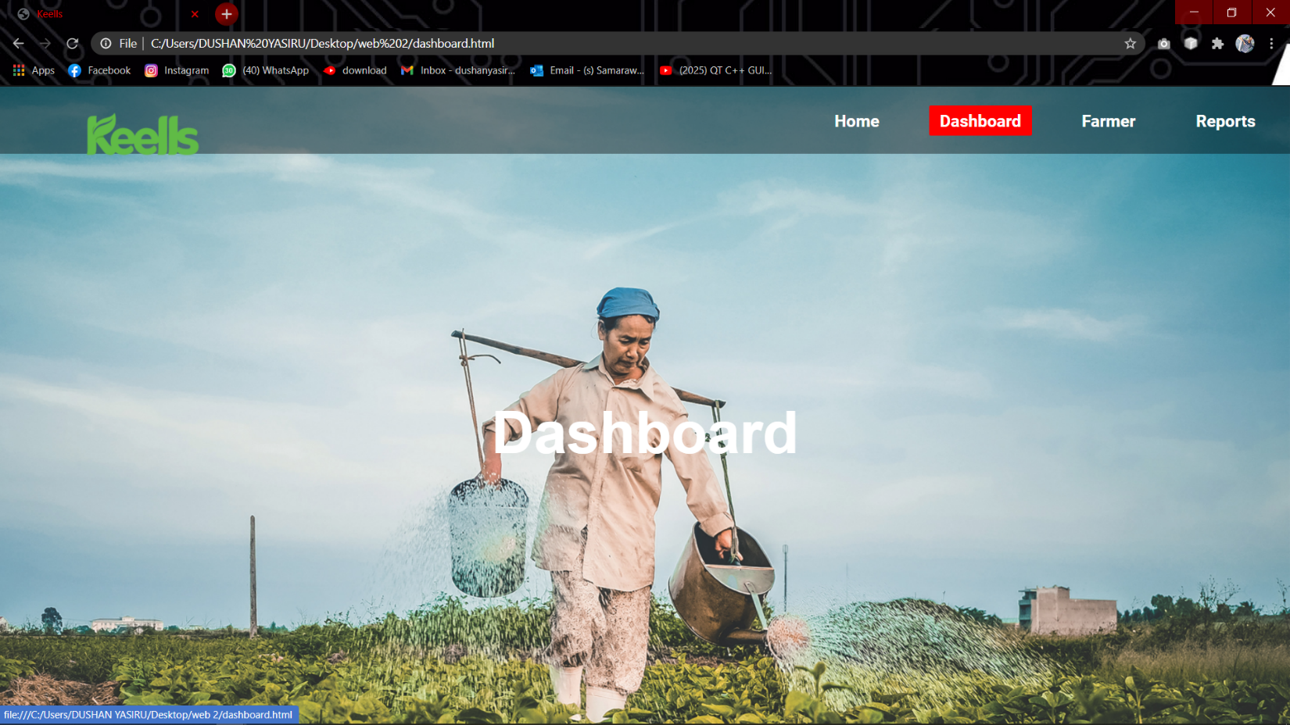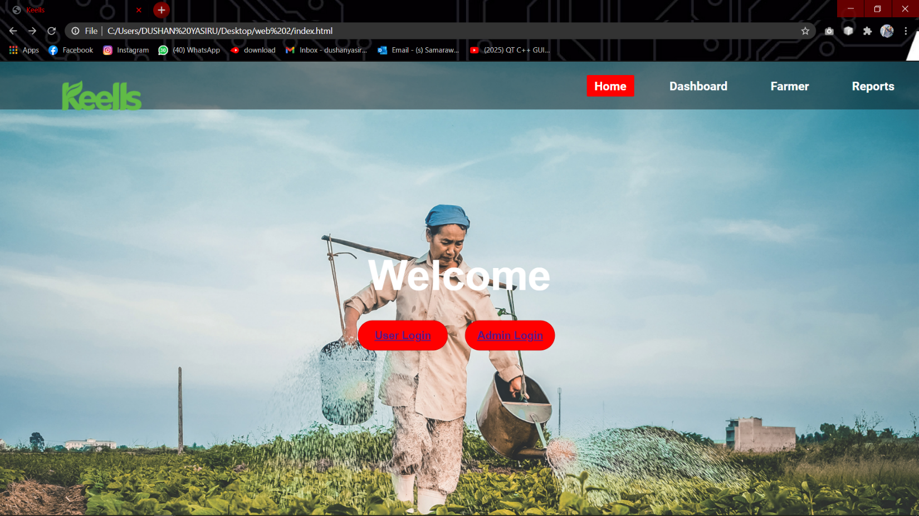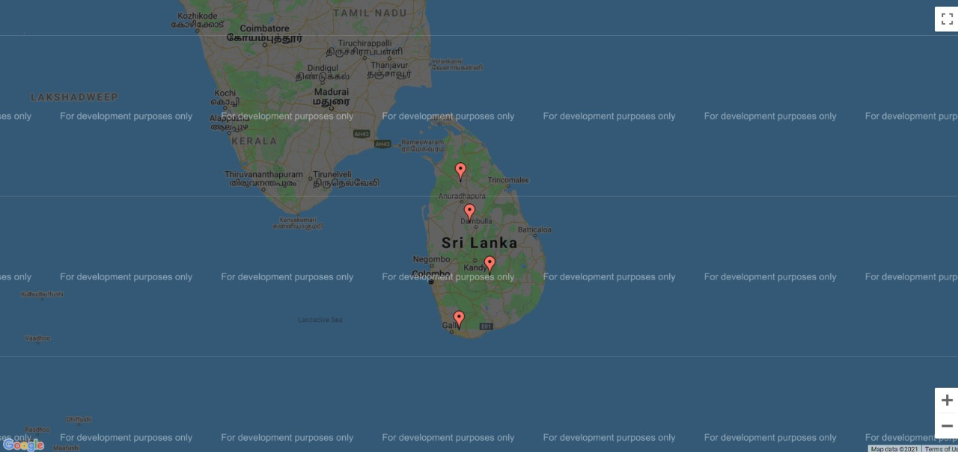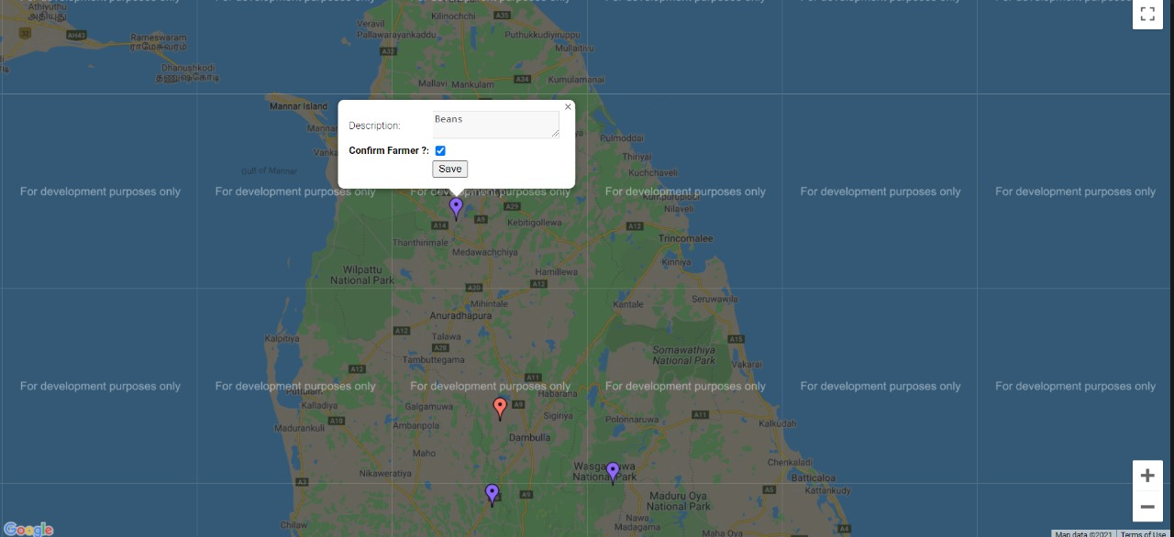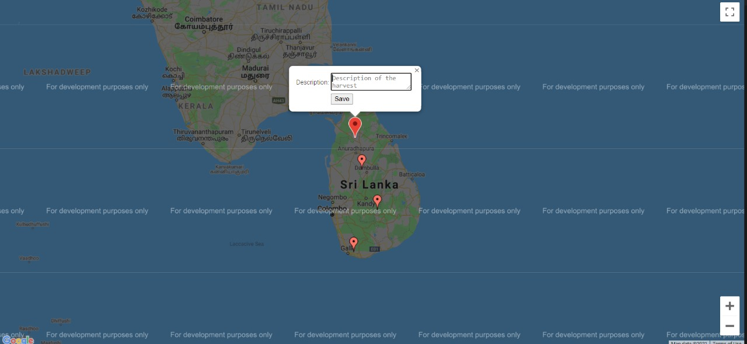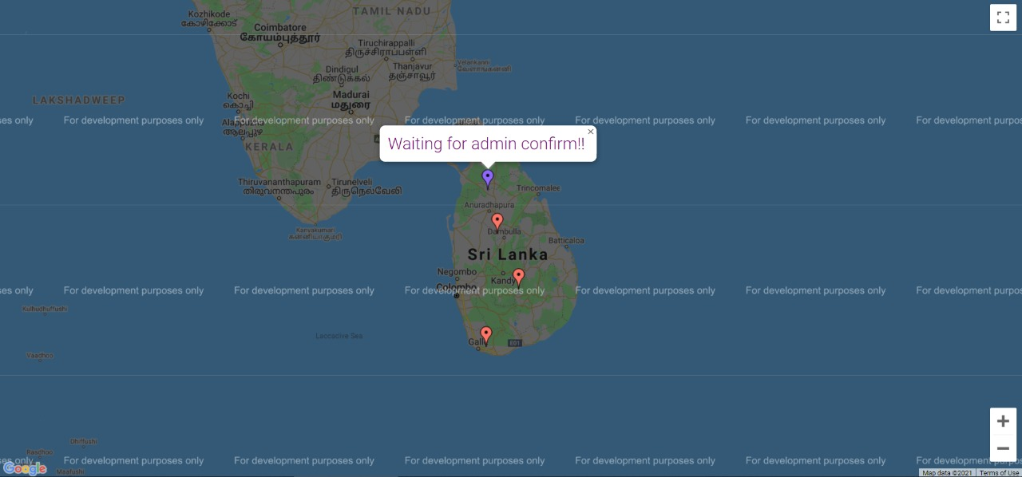

## **11. Summary**

The users do not require high educational levels, technical skills or advanced computer expertise to deal with this system. This platform is designed in a way that we can expand rapidly and add more functionalities and extensions efficiently.

The specification of the developed system is summarized below:

̵ An accurate system without any data redundancy

̵ Secured data storage

̵ Better graphical user interfaces

̵ Saving time and money via the computerization